This site was designed and created to be a personal website for myself to both show people some of my skills and for them to learn a bit more about me as a person. The home ages goal is meant to give people an introduction to who I am, what I like, and some of my experiences without going into my professional qualifications and the Gallery page is meant to support this with photos of my friends, family, and myself. The resume pages goal is the opposite of the home page, it is meant to show my professional qualifications and also includes download links to some programs I have built in the past in order to showcase my skills. The contact me page is fairly self-explanatory it is meant to allow people who are interested to contact me and find out more about either side of who I am. All of these pages are of a similar theme so they are all operating under the same CSS template while the JavaScript pages have a different design.

The pages with a focus on Java Script are meant to showcase my knowledge of the language and ability to implement it in a variety of ways. The calculator page is fairly simple, it has the added functionalities of powers and square roots from older calculators we’ve made plus the ability to copy in an answer into either portion of the next calculation. The game is a bit more complicated generating a random number and keeping track of the number of guesses the player has attempted to determine if they win or lose. The most complicated of the pages is the converter, which can take any of four separate number system inputs and convert them to any other of those 4 number systems. This works on a recursion based principle and while short was by far the most complex of the pages. All of these pages had the additional functionality of having the CSS of the pages edited by the Java Script at runtime when buttons were clicked, allowing the buttons to change color to indicate which are selected.

The audience of this site is simply anyone who wishes to know more about me, whether that be a potential employer or just an acquaintance. With that in mind this site was kept semi-professional in style and tone.

As far as critical features go I’d say the home page, resume, and converter are the main pieces of this site and that the rest is mostly supplementary. I say this because they cover all three of the main points of this site which were to learn about me personally and professionally and to demonstrate my skills in Java Script.

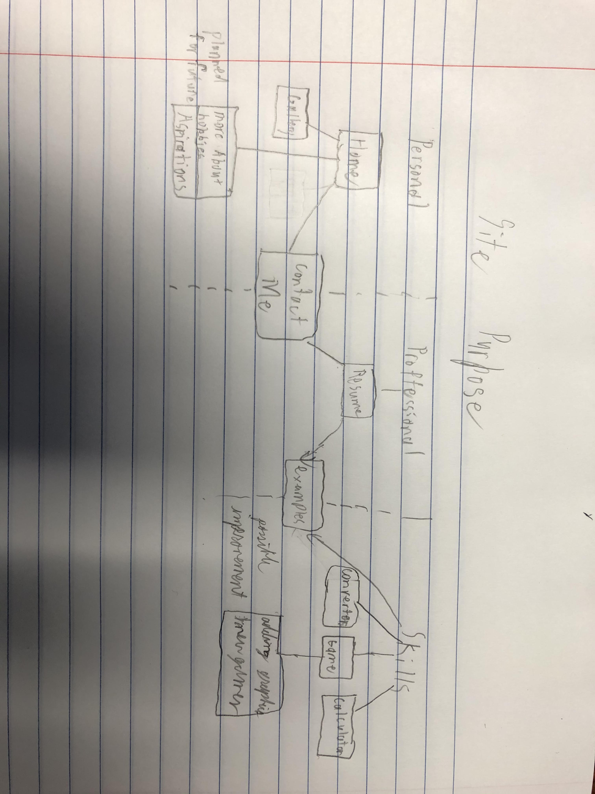

When implementing the site I started by making the bare bones of the JS pages and ensuring that their scripting element worked properly. After that I started working on its CSS to make it more visually appealing, I took a lot of inspiration from our in class examples when designing the look of these pages and had all the JS pages run off a single CSS style sheet. After that was completed I began working on the content page. These had separate a separate CSS page that was somewhat similar to the JS page one but changed their look considerably, I wanted a clear separation between the JS enabled pages and the standard informational web pages. These I worked on the CSS as I went, creating a basic template for all of them to start with then editing it for the needs of each individual page as I added content to give it the look I wanted. I chose to go with a sky theme for the colors as I found it relaxing and used a picture I took out west to emphasize the color choices of the blue background and white, cloud like, text boxes. For the java script components each page with JavaScript had its own script file written from scratch, I would often translate over old java or C codes to help with these. For expanding the site my main focuses would be to first expand the resumes portfolio section to include more work. After that I would like to improve on the game, perhaps make one with some basic graphics like an old school dungeon crawler. I would also like to expand on the pages about me personally, go into more detail about my hobbies and aspirations as well as talk more about challenges I have faced. The parts of this project that I am the most pleased with are the converter JavaScript because of it relative complexity and the overall CSS of the site, I think it turned out very visually appealing without being gawdy or over the top. I’d say the parts of this project that need the most work are the gallery and the home page. I think adding a carousel would have been a nice touch and increasing the amount of content would have also been good. I could have also made my JavaScript applications more robust by adding in more error detection mechanisms.